Press release.

EVOC PRODUCT HIGHLIGHT SPRING SUMMER 2022:
HYDRO PRO: Race-Ready, Adventure-Minded Hydration

Achieving the perfect hybrid between smart hydration backpack and well-ventilated vest, EVOC HYDRO PRO is the ideal hydration reserve for everything from gravel adventures to enduro races. Designed specifically for high-performance cycling applications HYDRO PRO is available in two different volumes — 1.5 l and 3 l.

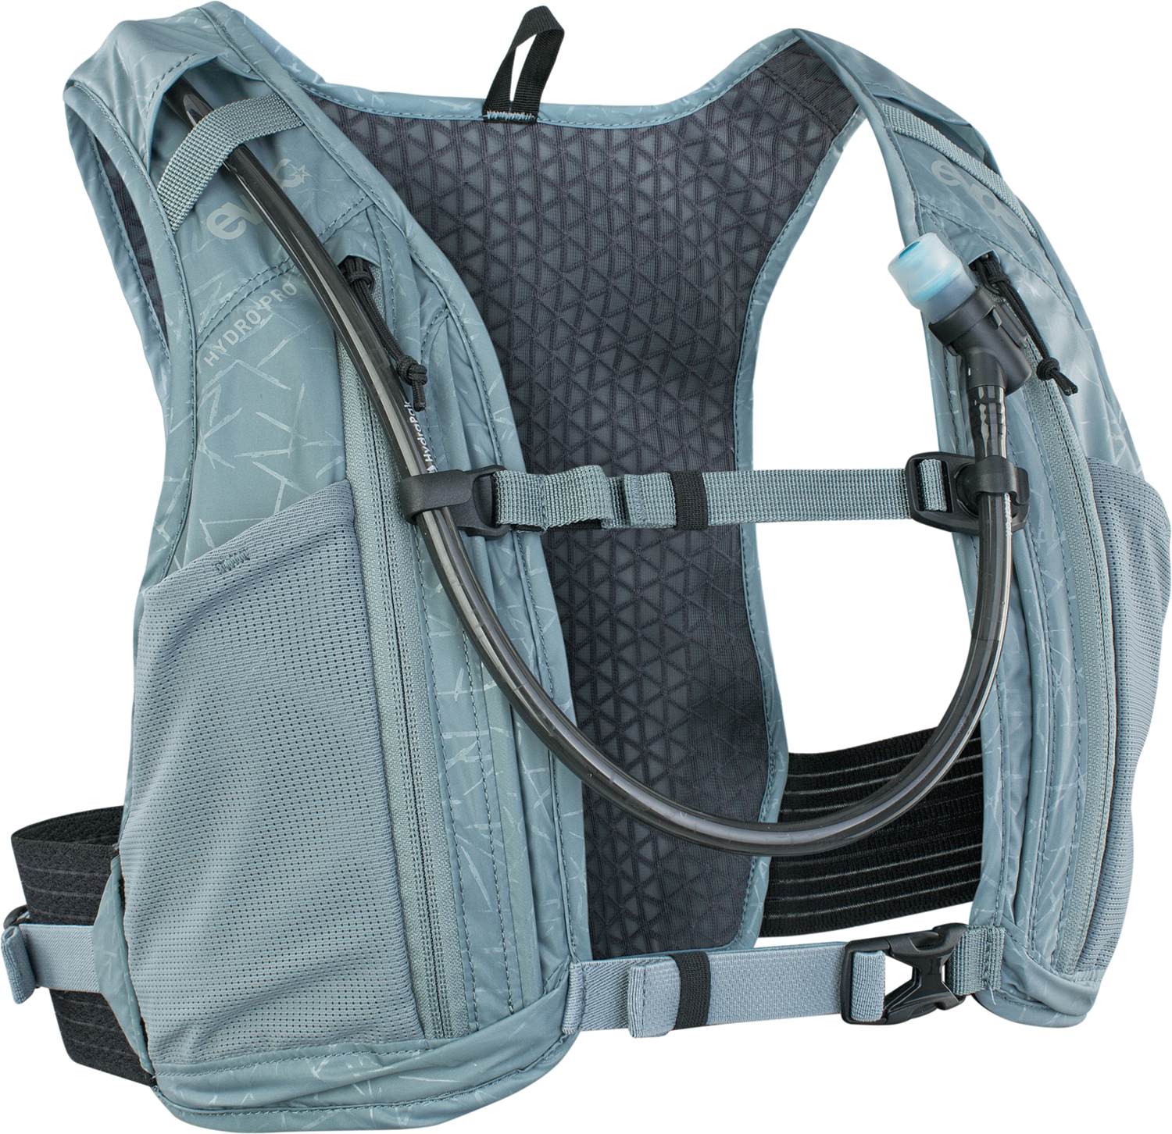
- The quick-access main compartment accommodates a 1.5-liter hydration bladder as well as smaller items and valuables.
- Two 150 ml mesh pockets on the shoulder straps ensure energy bars and gels remain within easy reach throughout any ride (or they can accommodate mini flasks for running)
- A zippered pocket — two on the 3l model — underneath the mesh pouches let are perfect to stow away mini tools or a mobile phone.
- The lateral AIRO FLEX sections keep the pack snug, yet comfortable, and prevent any side-to-side movement no matter where the road — or trail — takes you

Specifically designed to meet our athletes’ strict requirements without a single gram of unnecessary weight and good ventilation, HYDRO PRO is vital to maintaining fueling and hydration during summer events where high heat and dry conditions can limit athlete performance. The short-contoured HYDRO PRO creates a hydration solution for athletes without too much coverage on the rider’s back and allows for unencumbered use of the jersey pockets.

Further convenient features:
- HYDRATION BLADDER 1,5 included
- Mesh ventilation
- Body Hugging system for better fit
- Compression straps that prevent the load from jumping around inside the pack
- AIRO FLEX belts for flexible, yet firm fit
- Compartment for hydration bladders up to 1.5 litres
- Clip to attach hydration system hose
- Height-adjustable chest strap with clip to attach hydration system hose

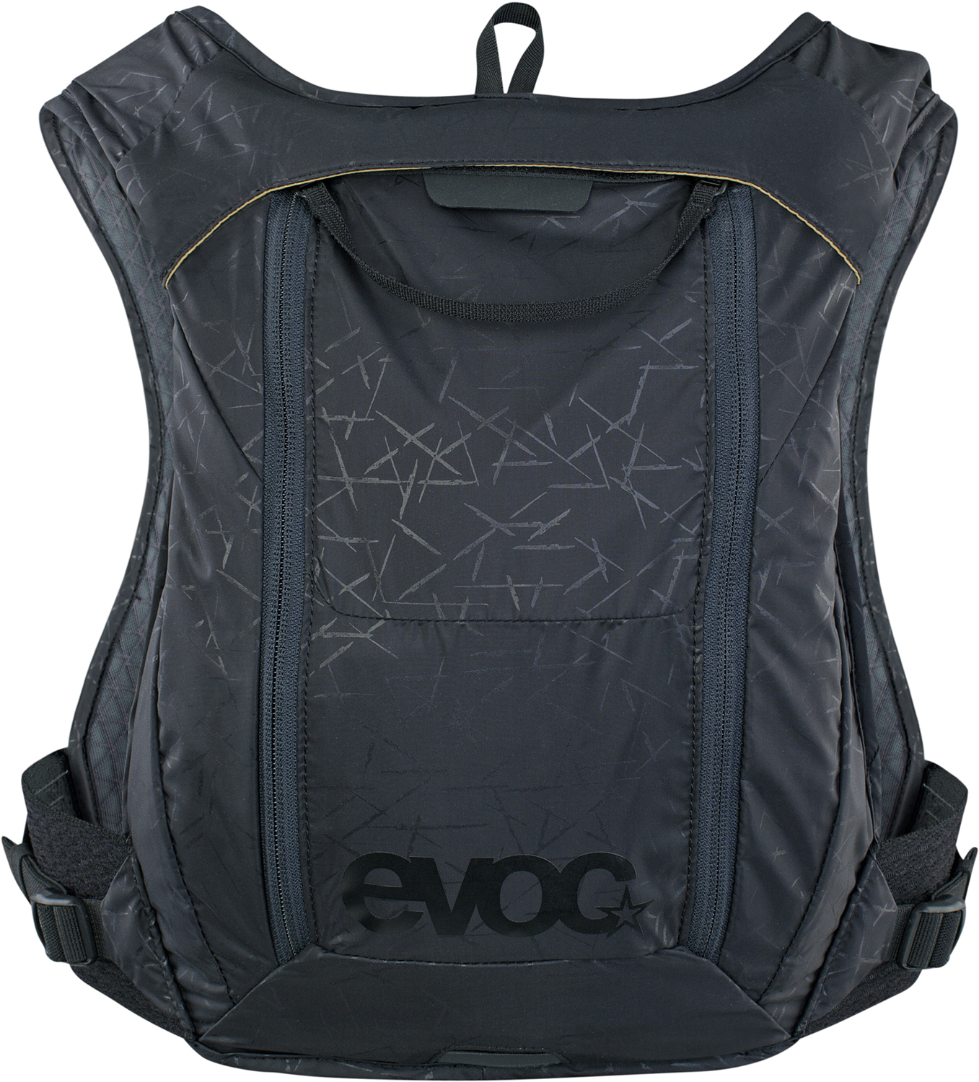
HYDRO PRO 1,5:
1.5 l (0.2 l in the chest pocket, 1.3 l in the pack), 230 g, 23 x 33 x 2 cm
Colours: Black, Steel
Materials: N210 D TAFFETA, 3D AIR MESH, AIRO FLEX
Price: 100,- € / 115,-$ (US)
HYDRATION BLADDER 1.5 included

HYDRO PRO 3:
3 l (1 l in the two chest pockets, 2 l in the pack), 250 g, 23 x 33 x 4 cm
Colours: Black, Steel
Materials: N210 D TAFFETA, 3D AIR MESH, AIRO FLEX
Price: 110,- € / 125,-$ (US)
HYDRATION BLADDER 1.5 included

Available from summer 2021
#EVOChydration

Royalty free photos for download in the EVOC Press Room

Date: July 2021
Subject to changes.

Media Contact: EVOC Press | press@evocsports.com |
USA & CAN PR Logan Van Bokel | logan@hotroutemedia.com |

